Case Study Template
Use this document to write your case study. If you haven’t filled out the Google form with the Stand Information yet, go to https://z.umn.edu/GLSLcase.

You may wish to review existing case study content as you prepare yours. There are lots of examples on the Silviculture Library site. You can also click here to view a playlist describing how to translate the documentation you have already prepared in the course of your work into a case study.

When you are ready to submit your case study for review, simply email this document and your photos to Lane Moser at moser196@umn.edu. If you have questions, contact Lane.

If you have previously submitted a case study using the old template, a major update to this template is that we can integrate photos throughout the case. Place photos in this case study document where you’d like them to appear on the final case study published on the website.

You do not need to complete every section, but you should if the data / information is available. More complete submissions are preferred.

Case Study Title

Featured Image
One image that will be used as the “cover” for the case study.

Stand Information

Latitude

Longitude

Nearest city or town

State/Province

Landowner

Describe the location.
Briefly describe the stand location. Example: Pine Tree District, XYZ National Forest.

Covertype
Covertypes include: Aspen-Birch, Ash, Central hardwoods, Mixed Woods, Northern hardwoods, Pine, Peatlands, Spruce, or Other

MN ECS Native Plant Community System
NPCs include: Acid peatland, fire dependent, floodplain, forested rich peatland, mesic hardwood, other MN ECS, and wet forest.

Kotar habitat type
We should have all forested Kotar systems; if we do not, please reach out to Lane Moser at moser196@umn.edu.

Plant community detail and growth stage (if available)

Forest health threats
Choose all that apply. We have a total of 18 options, the full list of which can be found at the very end of this template.

Adaptive silviculture options
This is for cases using the Adaptive Silviculture for Climate Change framework, described here: https://www.adaptivesilviculture.org/. If your treatment uses a Resistance, Resilience, or Transition strategy, note it here.

Estimated year of stand origin

Additional Information on Stand Origin
Comments on year of stand origin (one sentence only)

Site Index: _______ units: _______ for species: _______

Silviculture system
Choose all that apply, including: clearcut, group selection, other silviculture system, seed tree, shelterwood, single-tree selection.

Brief Silviculture Objective
Brief silvicultural objective (1 sentence). You will be able to elaborate below. This is the text that appears on your case study pin on the map, it should be brief and descriptive.

Site preparation method:
Choose all that apply. We have 16 options, the full list of which can be found at the very end of this template.

Predominant soil texture
Options include all those found on the soil texture triangle, as well as muck, and peat.

Soils details
This is a space to provide further information about soils on the site, including series name if available

Stand area: _____ (rounded to the nearest integer) acres or hectares?
Treatment area: _____ (rounded to the nearest integer) acres or hectares?

Submission month and year:

Case Study Body

Overview
Enter an overview of this case

Bottomland Hardwoods
If this is a bottomland hardwood case please complete the following fields
River or stream name:

River or stream type:
Select one that best describes your site:
Major river (e.g. Mississippi, St. Croix, Chippewa, Black, Wisconsin)
Minor river or upper reaches of major river (e.g. Cannon, Zumbro, Root, Mississippi Headwaters)
Perennial stream
Seasonal (intermittent) stream
Rainfall-dependent (ephemeral) stream
Floodplain or terrace:
Select one
Floodplain topographic position:
Select any that apply.
Point bar (All river types, floodplains only)
Natural levee (All river types, floodplains only)
Bottom (All river types, floodplains and terraces)
Slough (Major rivers, minor rivers, floodplains only)
Ridge (Major rivers, minor rivers, floodplains and terraces)
Ridge and swale (Major rivers, minor rivers, floodplains and terraces)
Swamp (Major, minor rivers, floodplains and terraces)

Silviculture Objectives
Add some detail to the brief silvicultural objective statement from above. This could include climate change considerations, secondary or other objectives. The prescription is a separate field, below.

Pre-treatment stand description and condition
(Address as many of the following as reasonable and appropriate)

Stand establishment and management history

Pre-treatment species composition

Pre-treatment growth and stocking
Include a stocking table or diameter distribution as appropriate, if available.

Table 1: This is an example table that has been directly copied over from Excel. All tables need a label (e.g. Table 1) and descriptive text above them.
Plot ID | Tree # | spp code | DBH (cm) | LCR (10%) | Height (ft) | Height (m) | Status (L/D) | Vigor (0/1/2/3)
E2 | 1 | ACSA | 20.9 | 60 | 36 | 10.9728 | L | 3
D4 | 1 | ACSA | 28 | 30 | 41 | 12.4968 | L | 2
D3 | 1 | ACRU | 21 | 50 | 43 | 13.1064 | L | 3
D3 | 2 | POGR | 15.1 | 30 | NA | NA | L | 3
D2 | 1 | ACRU | 22 | 40 | 46 | 14.0208 | L | 3
D2 | 2 | ACRU | 18 | 50 | NA | NA | L | 3
D2 | 3 | TIAM | 35.4 | 50 | NA | NA | L | 3
D2 | 4 | POTR | 14.8 | 40 | 34 | 10.3632 | L | 3
D1 | 1 | QURU | 47.3 | 50 | 65 | 19.812 | L | 3
D1 | 2 | ACSA | 18.6 | 40 | NA | NA | L | 3
D1 | 3 | QURU | 34.8 | 60 | NA | NA | L | 3
D1 | 4 | ACSA | 17.9 | 50 | NA | NA | L | 3
CS1 | 1 | POTR | 12.7 | 40 | 42 | 12.8016 | L | 3
CS1 | 2 | SNAG | 20 | 0 | 16 | 4.8768 | D | 0
CS1 | 3 | ACSA | 29.9 | 30 | NA | NA | L | 1
CS1 | 4 | ACSA | 34.4 | 60 | 40 | 12.192 | L | 3

Pre-treatment forest health issues

Landowner objectives/situation

Silviculture Prescription
Silvicultural prescription, including target regeneration stocking and residual stand conditions, harvest area size(s) and arrangement, species to reserve or harvest, harvest season, regeneration plan (if applicable), use of timber harvest guidelines, and plans for future treatments. Should be pretty specific with target numbers, not just general statements. 250 words.

What actually happened during the treatment
What actually happened during the treatment? Type of equipment used, changes made during treatment and why, what went well and not so well, surprises, etc. 250 words.

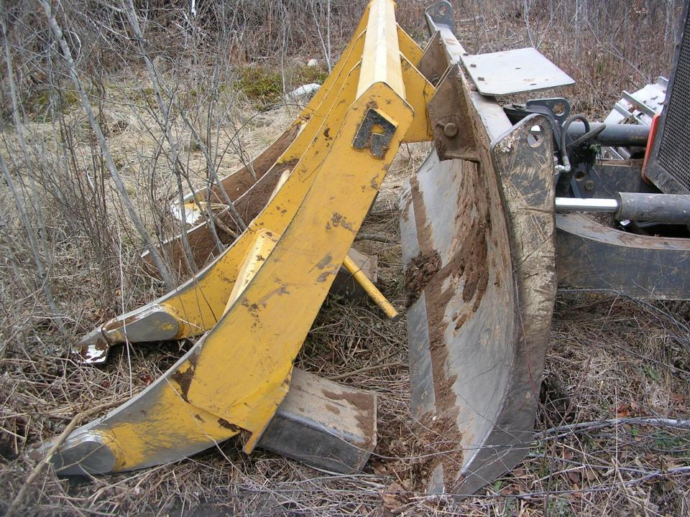
Figure 1: This is an example description for a photo of a salmon blade. Figure descriptions go under the photo or graphic. Figures should be numbered in the order they appear.

Subsequent entries
If there were multiple entries with this treatment, further management actions, etc. they can go here (e.g. removing the overstory in a shelterwood, release of regeneration).

Post-treatment assessment
Consider the following – only those applicable to your treatment: Stocking, distribution, and condition of residual trees; stocking and distribution of regeneration / survival of planting stock; and other site impacts relevant to the prescription, positive or negative.

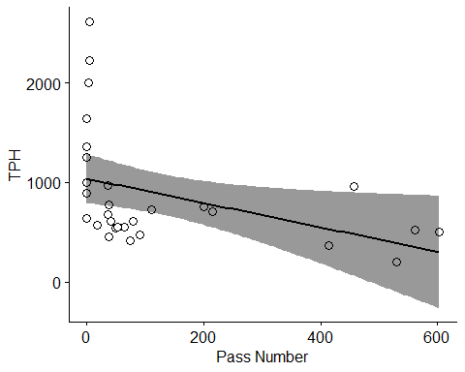
Figure 2: This is another example figure. Photos can now be placed throughout a case study where their placement is most relevant to the written content.

Assessment follow-up
Delineate any follow-up assessments here, e.g. returning to the stand for a 3- or 5-year check.

Plans for future treatments

Costs and economic considerations
If possible, break down by treatment components: Time estimate to lay out / plan, time to harvest, timber sale revenue, site prep or other costs, etc.

Climate adaptation considerations
How did climate adaptation considerations influence your prescription?

Other notes

Summary / lessons learned / additional thoughts
What would you do differently if you could do over? Could include climate change considerations or other. 200 words

Supplemental content
Optional. Shapefiles, data tables, historic airphotos, or others. When submitting this case study document and photos, please also include any supplemental content you’d like to include, along with the descriptions.

appendix_1_forest_plan_objectives_manitou_patch_project.pdf
This is an example description for a PDF document that may be of interest to the audience but is not necessary to understand the case study treatment.

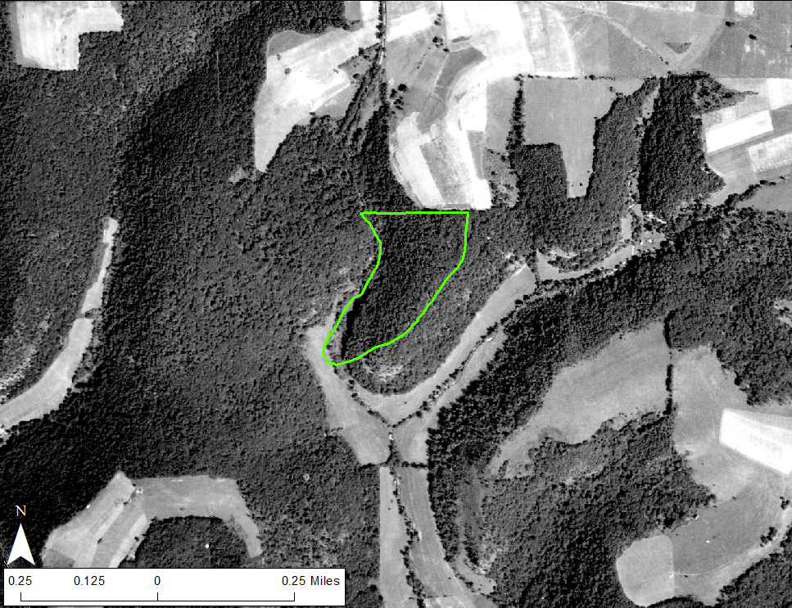
Supplemental figure 1: This is an example description for an air photo from 1938.

Authorship

List of author/s

Author information
(Optional. We hope to use the silviculture library to build relationships. We would love to include a couple of sentence bio for each author and a small head shot. If you and/or your co-authors have already submitted a case study, you do not need to fill out the author information again.)

Name

Title

Organization

Photo

Phone Number

Email

Address

City, State/Province, Postal code

Biography

Forest health threat/site preparation method list
